* Bean Validation 2.0
* This version requires Java 8 or higher
* **B1: Setup (install library)**

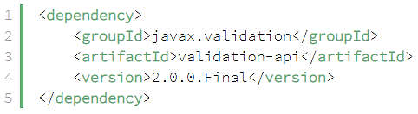

*JSR 380*

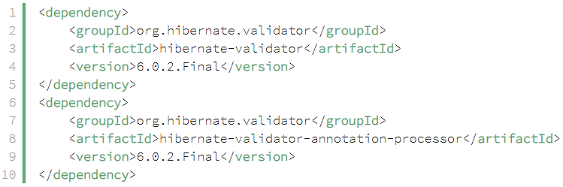

*Hibernate validator*

*(tách biệt với hibernate)*

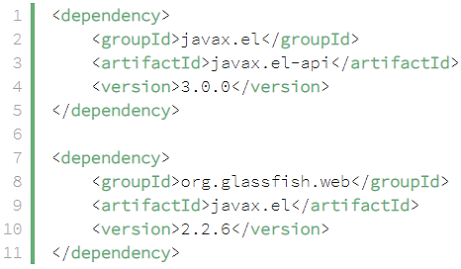

*Expression Language Dependencies*

[*https://www.baeldung.com/javax-validation*](https://www.baeldung.com/javax-validation)

[*https://hibernate.org/validator/documentation/getting-started/*](https://hibernate.org/validator/documentation/getting-started/)

* **B2: Config Annotation**
  + **Apply on entity’s attribute**

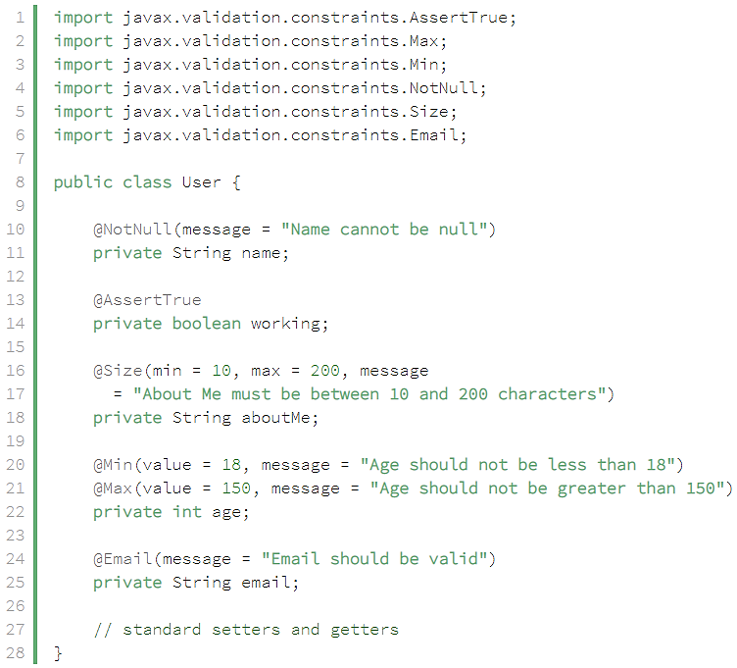

* + **Apply on List**



* + **Apply on parameter**

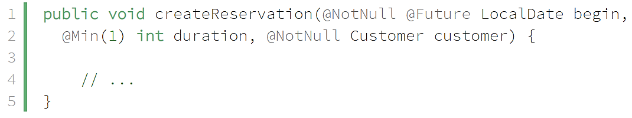

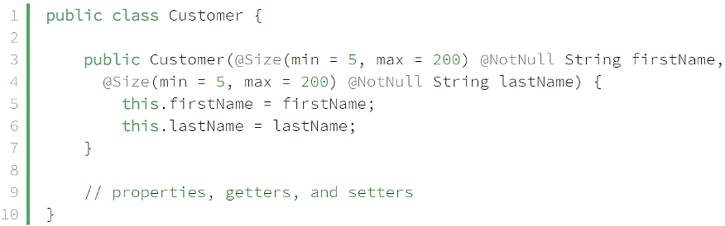

*constructor*

* + **Apply on constructor**

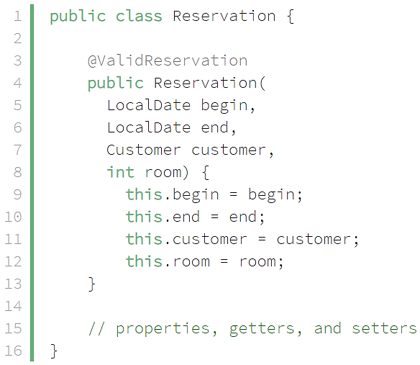

*Constructor*

*Xem thêm custom method validator*

* + **Apply on method**

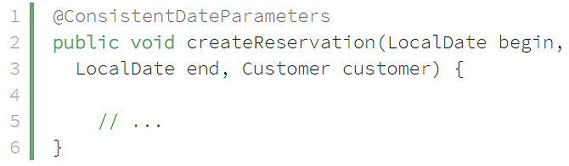

*Xem thêm**custom method validator*

* + **Return Value Constraints**

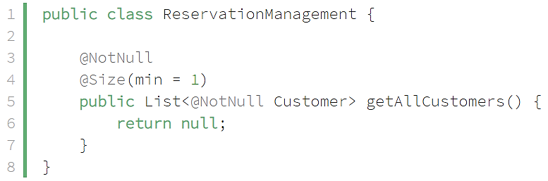

* + **Cascaded Validation**

Validate các complex object

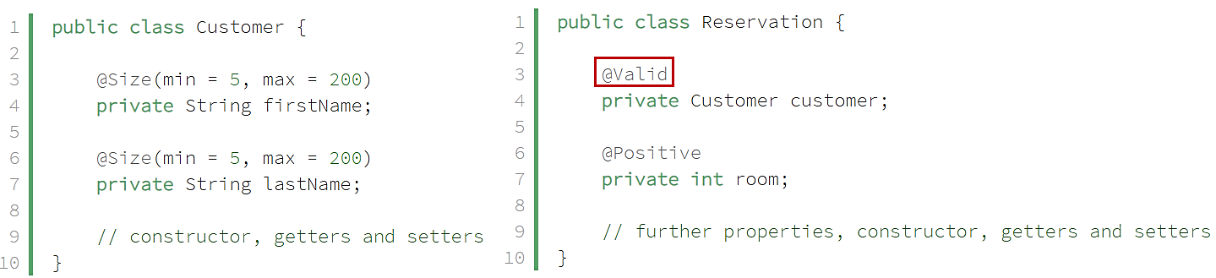

*@Valid*

|  |  |
| --- | --- |
| *Apply on parameter* | *Apply on return value* |

* **B3: Validate**
  + **Java Basic**

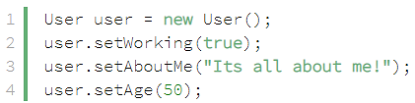

*Object validation*



*Create Validator Object*

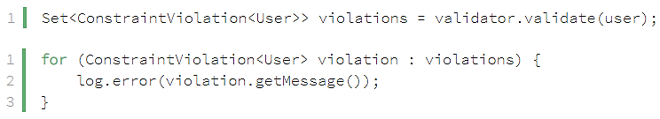

*Validate*

* + **Spring**

Xem trong Spring validation

* **Reference**

https://github.com/eugenp/tutorials/tree/master/javaxval

<https://hibernate.org/validator/documentation/getting-started/>

<https://beanvalidation.org/2.0/>